

SMPS-Based Bench Power Supply
MCT 225:Power Electronics and Drives

Team Member Name | Student ID
Mostafa Ahmed Moatamed | 192300228
Adham Ahmed Fauozy | 192300299
Mohamed Yasser Salah | 192300238
Zyad Mohamed Saeed | 192300264
Ali Hossam Mohamed | 192300140
Abdelrahman Hany Salah | 192300233

Supervised by:

Dr.Ashraf Samir
Eng.Hazem Hossam
Department of Mechatronics Engineering
Faculty of Engineering and Technology
Academic Year 2025–2026

Table of Contents
Abstract 2.
1. Introduction 2
2. System Overview 3
3. Input Stage and Protection 3
3.1 3.1 AC Input 3
3.2 Dual Voltage Operation (110V / 220V) .3
3.3 Fuse Protection 4
3.4 NTC Thermistor 4
4. EMI Filtering Stage 4
5. Rectification and DC Bus 5.
5.1 Bridge Rectifier 5
5.2 Bulk Capacitor 5
6.High-Frequency Switching Stage 5
7. Transformer Stage (Flyback Operation) 5
8. Snubber Circuit 6
9. Secondary Side 6
9.1 Fast Recovery Diode 6
9.2 Output Filtering .6
10. Feedback and Regulation 6
11.SMPS Output Design 6
12.Post-Regulation (Buck Converter Stage) 7
13.Buck Converter Protection 8
14.Output Monitoring and Display 8
15.Thermal Considerations 9
16.Practical Design Observations 9
17.System Advantages 9
18.Conclusion 10
References 10

Abstract
This report presents the design, implementation, and analysis of a regulated DC power supply that combines a flyback SMPS stage with a DC-DC buck converter. The system converts AC mains input into a controlled DC output with a maximum voltage of 27.4 V, followed by a post-regulation stage that enables fine adjustment of voltage and current. The design emphasizes efficiency, protection, and compatibility between stages, with additional features such as dual input voltage selection (110V/220V) and real-time output monitoring.

1. Introduction
Modern electronic systems require stable and efficient power supplies. Linear regulators, while simple, are inefficient at higher power levels due to heat dissipation. For this reason, switch-mode power supplies (SMPS) are widely used.
In this design, a two-stage approach is adopted:
- A flyback SMPS converts AC to a regulated DC level.
- A buck converter (post-regulation stage) provides fine control over the output.
This architecture combines high efficiency with flexibility and precise control.

2. System Overview
The system operates through a sequence of energy conversion stages:
- AC input and protection
- EMI filtering
- Rectification and DC bus formation
- High-frequency switching
- Transformer isolation (flyback)
- Secondary rectification and filtering
- Feedback regulation
- Post-regulation (buck converter)
- Output monitoring
Each stage contributes to the overall performance and reliability of the system.

3. Input Stage and Protection

3.1 AC Input
The circuit is powered from AC mains. Proper insulation and connection are required to ensure safety.

3.2 Dual Voltage Operation (110V / 220V)
The SMPS supports two input modes:
- 110V AC mode
- 220V AC mode
Selection is done using a DPDT (Double Pole Double Throw) switch.

Operation:
- In 220V mode, the circuit works as a standard bridge rectifier.
- In 110V mode, the circuit reconfigures into a voltage doubler, ensuring that the internal DC bus reaches the required level.

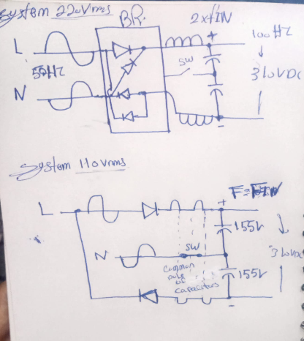
Important Note: Incorrect switch selection can lead to severe damage. For example, applying 220V while the circuit is set to 110V mode may overstress capacitors and semiconductors.

3.3 Fuse Protection
A fuse is placed at the input to protect against overcurrent and short circuits. It disconnects the circuit under abnormal conditions.

3.4 NTC Thermistor
The NTC limits inrush current during startup. This protects the rectifier and bulk capacitor from high surge currents.

4. EMI Filtering Stage
An EMI filter is used to reduce electrical noise. It prevents switching noise from affecting other and improves system stability.
Typical components include:
- Common-mode choke
- Capacitors across and between lines

5. Rectification and DC Bus

5.1 Bridge Rectifier
The AC input is converted into pulsating DC using four diodes.

5.2 Bulk Capacitor
A high-voltage capacitor smooths the DC and creates a stable bus voltage used by the switching stage.

6. High-Frequency Switching Stage
Although the signal is now DC، it cannot directly drive a transformer. Therefore, a PWM controller and MOSFET are used to convert it into a high-frequency pulsating waveform.
This waveform behaves like AC, allowing transformer operation.

7. Transformer Stage (Flyback Operation)
The transformer operates in flyback mode.

Key Functions:
- Electrical isolation
- Voltage step-down
- Energy storage and transfer
Unlike conventional transformers, energy is stored during the ON time of the MOSFET and released during the OFF time.

8. Snubber Circuit
An RCD snubber is used to suppress voltage spikes caused by leakage inductance. This protects the MOSFET and improves reliability.

9. Secondary Side

9.1 Fast Recovery Diode
Converts the high-frequency waveform into DC.

9.2 Output Filtering
An LC filter smooths the output and reduces ripple.

10. Feedback and Regulation
A feedback loop is used to maintain output stability.

Components:
- Reference regulator (TL431)
- Optocoupler
The output voltage is continuously monitored and compared with a reference. Any deviation is corrected by adjusting the PWM duty cycle.

11. SMPS Output Design
The SMPS is designed to deliver a maximum output voltage of: 27.4 V DC
This value is carefully selected to:
- Ensure compatibility with the buck converter
- Avoid excessive voltage stress
- Maintain efficient operation

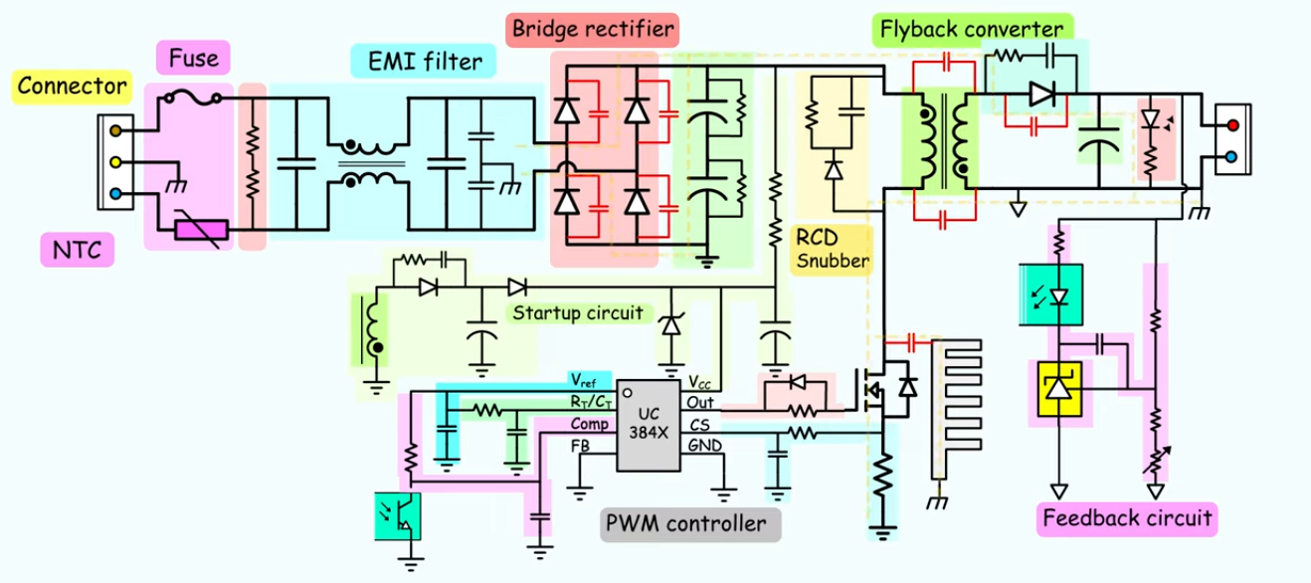

12. Post-Regulation (Buck Converter Stage)
After the SMPS, a buck converter is used for additional regulation.

Purpose:
- Fine voltage adjustment
- Current limiting
- Improved output stability
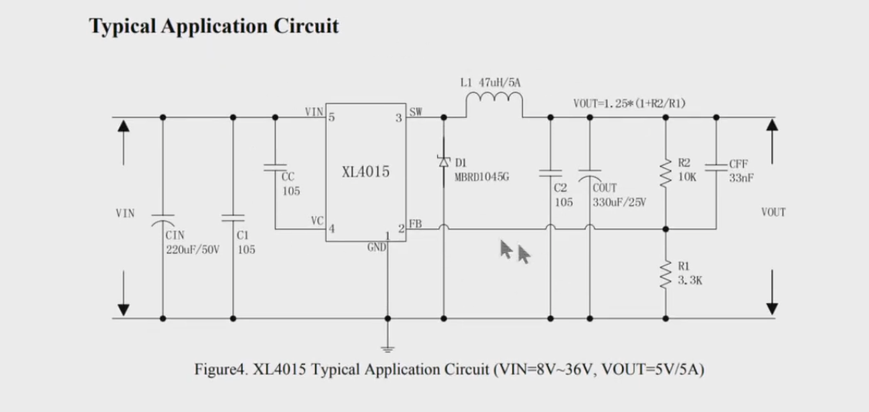
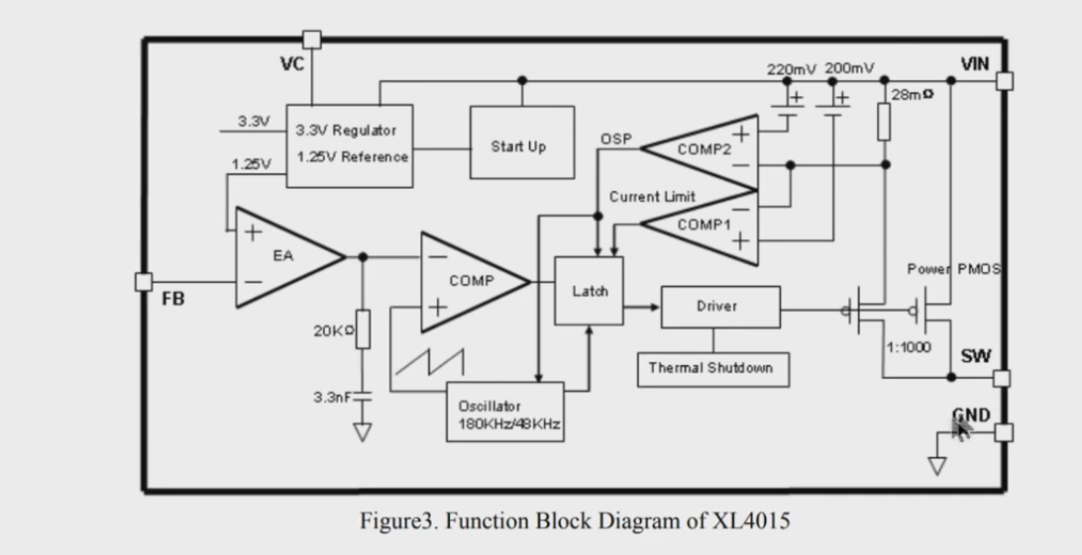
This stage allows the user to control the output according to load requirements.

13. Buck Converter Protection
A 5A fuse is placed at the input of the buck converter.

Reason:
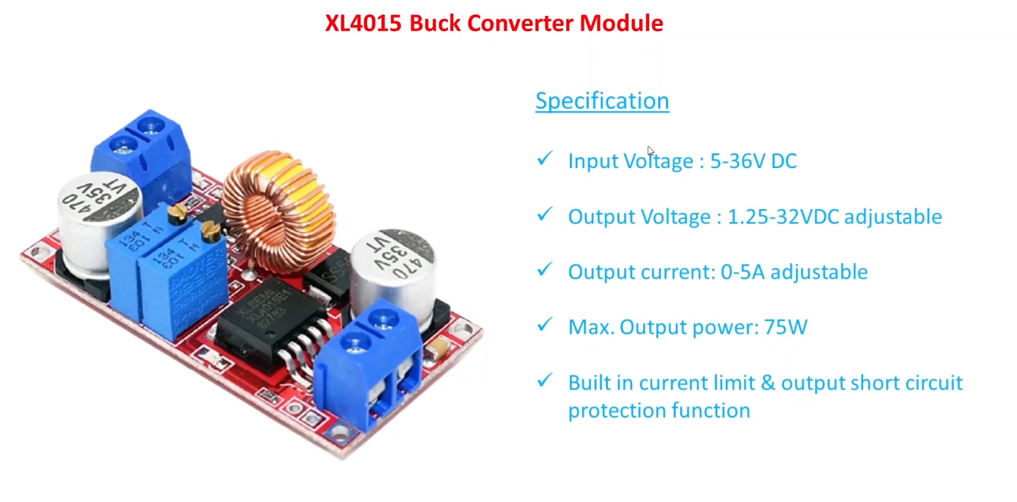
Although the system may deliver higher current, the buck module itself has practical limits. The fuse protects the converter from overheating or damage.

14. Output Monitoring and Display
A digital volt-ammeter is used to monitor system performance in real time.

Features:
- Displays output voltage
- Displays load current

Practical Benefit:
During testing, the display helps verify stability and detect abnormal conditions such as overload.

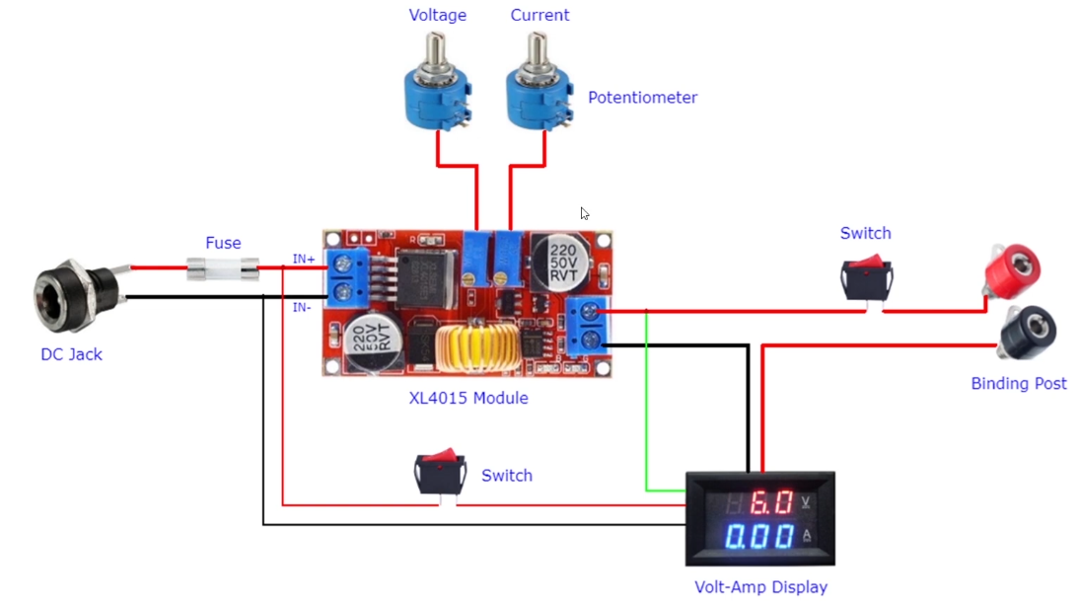

15. Thermal Considerations
High current operation results in heat generation. Proper thermal management is required:
- Heat sinks
- Adequate airflow
- Proper component spacing

16. Practical Design Observations
From practical implementation:
- PCB layout plays a critical role
- High-current traces must be wide
- Switching loops should be minimized
- Noise coupling should be reduced

17. System Advantages
- High efficiency
- Adjustable output
- Electrical isolation
- Multi-stage protection
- Flexible operation

18. Conclusion
The designed system successfully combines the efficiency of SMPS with the flexibility of a buck converter. By carefully selecting a maximum SMPS output of 27.4 V and implementing a post-regulation stage, the design achieves both stability and adaptability.
Additional features such as dual input voltage selection and real-time monitoring enhance usability and reliability, making the system suitable for practical engineering applications.

References
- Erickson & Maksimovic – Fundamentals of Power Electronics
- Marty Brown – Power Supply Cookbook
- Texas Instruments – SMPS Design Guides
- ON Semiconductor – UC384x Datasheet
- XL4015 Datasheet

